Elaborated by the EU GoH at FIL organisation team

Building a Union of Cultures

Newsletter
N°2 – February 2023
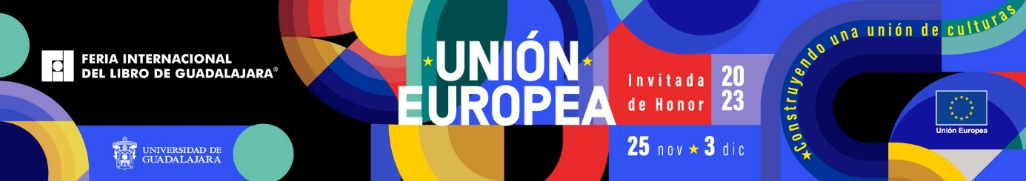

This is an internal communication support document aimed to disseminate project progress information among all relevant EU stakeholders.

Content

- The EU as Guest of Honour at FIL - Reminder
The EU has been invited to participate as Guest of Honour at the 37th Edition of the Guadalajara International Book Fair (FIL), in Mexico, from 25th November to 3rd December 2023.
The participation of the EU in the FIL will be placed under the motto “Building a Union of Cultures” and is an opportunity for the EU to promote its global presence and standing, reinforce mutually enriching links, build partnerships and enhance relations between the EU and the Latin America and Caribbean regions.

- The FIL in 2022 – the takeaways
FIL 2022 edition took place between 26th November and 4 December 2022. It revealed its current vitality, attracting more than 800,000 visitors, composed mainly of young people, over 1000 literary related events, 2,170 publishers, over 14,000 book sector professionals and 2200 journalists and press & media professionals, from over 40 countries. The popularity and communication outreach of last FIL edition has confirmed its positioning as a major global cultural event, very positive image and wide visibility.

- The EU Participation as Guest of Honour
The Guest of honour role has been handed over to the EU on 4 December 2022. Its programme is currently under elaboration, in close consultation with EU MS, competent Commission directorates and EU services, European cultural institutions and cultural and artistic operators.

- The EU 2023 Pavilion
The EU 2023 Pavilion at FIL project has been finalised. It covers 1180 mts² in front of the main entrance of the FIL premises. The EU Pavilion will offer spaces to host small format literary and artistic activities as well as digital interactive material displaying cultural, language and literature related content. A specific shared workspace will be exclusively dedicated to EU Member States book sector professionals.

- FIL delegation visit to Brussels
FIL management, including its President and General Director, has paid a visit to Brussels, from 13 to 16 February 2023 to work hand in hand with EU GoH organisational team. High-level encounters have been organised between the respective hierarchies. Close coordination between FIL and EU GoH aims at optimizing the organisational work and ensure a coherent approach between the parties.

- Contact with Member States
Current bilateral consultations are being held between the EU GoH curatorial team and EU MS officials to give shape to each MS participation in the EU-FIL event.
- The EU as Guest of Honour at FIL - The concept
The European Union has been invited to participate as Guest of Honour at the 37th edition of the Guadalajara International Book Fair, in Mexico (Feria Internacional del Libro de Guadalajara, FIL) from 25th November to 3rd December 2023.
FIL Guadalajara is the largest book fair in the Latin American region and in the Spanish speaking world, and the second largest in the world. Beyond its prominent role as a literature and book sector event and market, FIL is a major regional cultural event.
The participation of the EU in Guadalajara is placed under the motto “Building a Union of Cultures” and is an opportunity for the EU to promote its global standing, reinforce mutually enriching links, build partnerships and enhance relations between the EU and the Latin America and Caribbean regions (LAC), based on our respective intellectual capital and the diversity of our cultural assets, literatures, languages and heritage.
The participation of EU at FIL aims to build durable collaborations, reinforce trust with our partners, contribute to the expansion of the book/literature sector exchanges between both sides of the Atlantic and improve the perception and the understanding of the EU and its diversity.
As Guest of Honour (GoH) at FIL, the EU will have a prominent presence and a large pavilion at FIL and propose an artistic and literary programme.
The EU will encourage co-creation and showcase the dynamics of contemporary European culture, literature and artistic production. Young authors, artists, readers and general audiences will be given a prominent role.

The organisation of the participation of EU as GoH in FIL Guadalajara is jointly led by the EC and the EEAS with a Team Europe approach: All 27 Member States are consulted and the programme will be built in collaboration between EU and Member States’ institutions.
A team has been hired for the organisation of the EU participation at FIL, led by an ad hoc curator.

- The FIL 2022 – the takeaways
The 36th edition of the FIL took place between 26th November and 4 December 2022. The EU GoH at FIL organisational team participated in the fair and established a close collaboration with FIL management team, in view of the organisation of the EU participation in 2023.
The FIL 2022 edition was the first fully presential edition since the beginning of the pandemic. It attracted 806,000 visitors, including 184,000 children, who benefit from specific children’s books and artistic activities. Visitors are in their vast majority young people, mainly university students.
In 2022, FIL hosted over 1,000 literature related activities (debates, conferences, book presentations, etc.) with 775 writers from more than 40 countries.
2,173 publishers and over 14,000 book sector professionals participated in professional activities and market.
The artistic programme, which takes place in a vast covered open-air space near the expo centre with capacity for 3,000 people, also caters to a young public. The EU as GoH is expected to setup a 9 evenings artistic programme to be performed in this space. The EU programme ought to showcase EU artistic, regional, linguistic and cultural diversity, and be able to interest and attract local youth.
The artistic programme, as well as the whole GoH participation at FIL, benefits from a very large media coverage, communication channels and visibility, with FIL social media outreaching over 15 million individuals.
The presence of 2,200 journalists and press professionals from radios, TV channels, written press and online specialized media guarantee FIL a wide media visibility at a national level in Mexico. Some LAC media operators are also present throughout the FIL, reaching several LAC countries, if not all.

- The EU Participation as Guest of Honour
On December 4, 2022, the EU was handed over the guest of honour role from the Emirate of Shrarjah, FIL guest of honour in its 2022 edition.
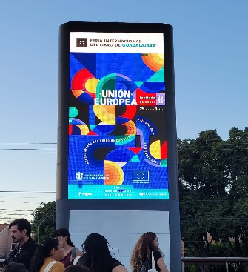
EU is already present in all FIL related communication supports, including street publicity displays in Guadalajara (image).
Current FIL visitors trend and the EU visibility and attractiveness as a guest of honour justify expectations of 1 million visitors during the 9-day fair in November 2023.
EU programme as guest of honour is currently being elaborated in close consultation with EUMS, competent Commission directorates and EU services, European cultural institutions and cultural and artistic operators. It will include a literary programme, an artistic programme, professional book sector activities, visual arts exhibits and a GoH pavilion, with its cultural content and own events. The University of Guadalajara organises a debate of ideas programme, in which the EU will be able to engage dialogue with LAC counterparts on its current state of scholarly and academic research as well social and cultural trends.
The 27 EU MS ought to be represented in the programme, showcasing European linguistic, artistic and cultural diversity, artistic contemporary creation and current state of scholarly and academic thinking and research.
The GoH participation is regularly inaugurated a day prior to the FIL official opening, in a ceremony staged at the University of Guadalajara Museum (MUSA), which offers large, high standard exhibit spaces and a prestigious assembly hall. The EU is expected to hold a similar inaugural event on Friday 24.11.2023. A visual arts exhibit will be organised by the EU in the MUSA for this occasion.

- The EU 2023 Pavilion
The EU 2023 Pavilion at FIL will cover 1180 mts² in a central and visible position within FIL premises. The Pavilion project has been conceived by the architectural studio External Reference, based in Barcelona.
The Pavilion will include an ample multipurpose agora-like space, two small multipurpose stages, a 150 mts² bookstore, an info-point and mediathèque area and a mezzanine dedicated to book professionals’ activities. Based on the number of last year’s figures, it is expected that the EU Pavilion will receive over half million visitors during the 9 days fair in its edition 2023.
The Pavilion will offer literary and artistic small format events, cultural content, multimedia literary and language related interactive screens and installations as well as a pool of young cultural mediators to engage dialogue and inform visitors on EU related content and EU GoH artistic and literary programme.

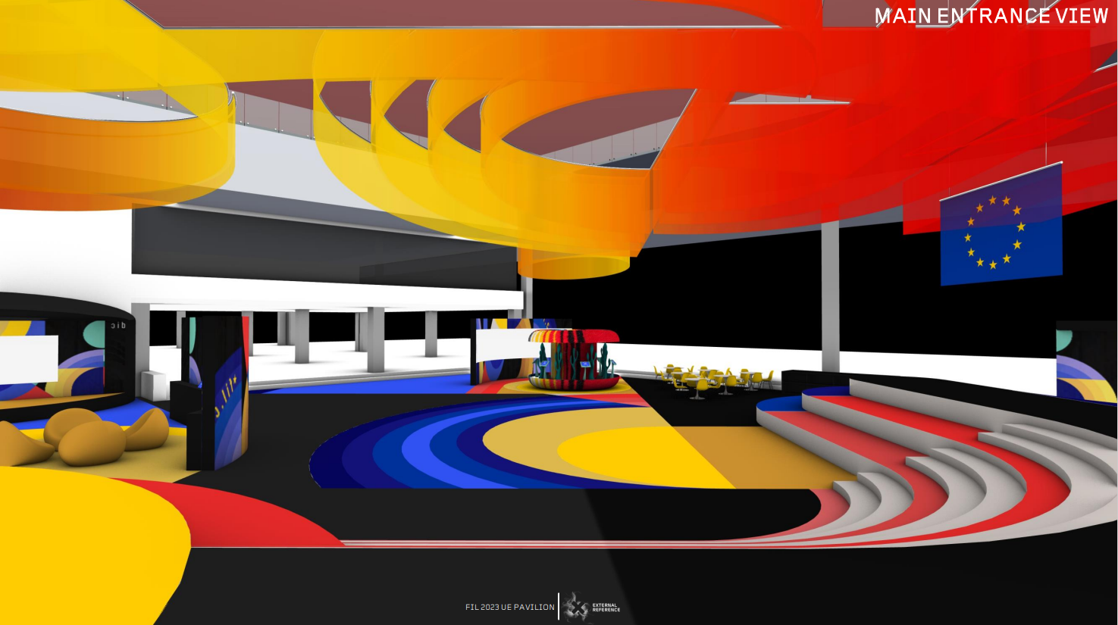

- FIL delegation visit to Brussels
A delegation of the International Book Fair of Guadalajara and the University of Guadalajara has visited Brussels between 13 and 16 February. The objective of the visit was to coordinate and finetune the organisational work towards the participation of the EU as GoH at FIL 2023. Daily meetings were organised between the FIL and the EU GoH respective organisational teams covering each of the different FIL sections in which the EU is expected to participate: Literary programme, book professionals’ activities, artistic programme, debate of ideas’ programme, science diffusion activities, visual arts, youth and children related activities.
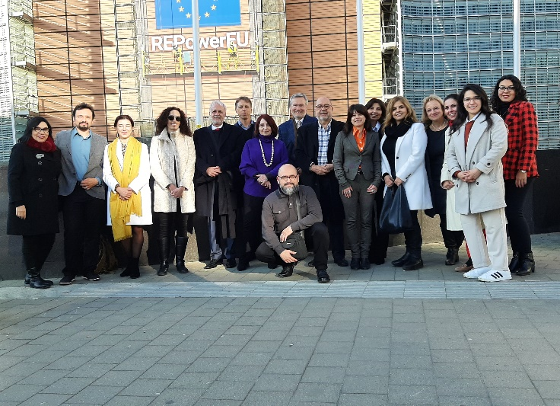
The work accomplished during this visit allowed to establish a precise timeline and clear common understanding of tasks to be undertaken to ensure a full and successful participation of the EU at FIL 2023. The participation of EU at FIL is understood by both as an action aiming to reinforce longer term relations and open sustainable cooperation opportunities between the parties.
Meetings with different EU related programmes and institutions allowed FIL delegation members to have a brief overview of the multiple intellectual resources developed and available around the EU, such as the Knowledge and Innovation Community (KIC) within the European Institute of Innovation and Technology (EIT), or the New European Bauhaus, among others.
The FIL delegation also held high-level meetings with EU officials, visited several cultural venues in Brussels, such as the House of European History, and was received by the Mexican Ambassador to Belgium for a reception.

- Contact with Member States
Bilateral consultations are being currently carried by curator Patricio Jeretic (supported on some specific questions by individual members of the EU GoH organisational team) and EU Member States focal points.
Each MS is expected to propose authors, book sector professionals, artists, scholars to be invited to the different EU GoH programme sections, as well as support their participation. The final list of guests is agreed by the parties, including FIL organisation team.

A first draft of the EU GoH programme (work in progress) should be ready and will be distributed to MS by end of March 2023.

